**ONLINE VOTING SYSTEM**

USECASE DIAGRAM:

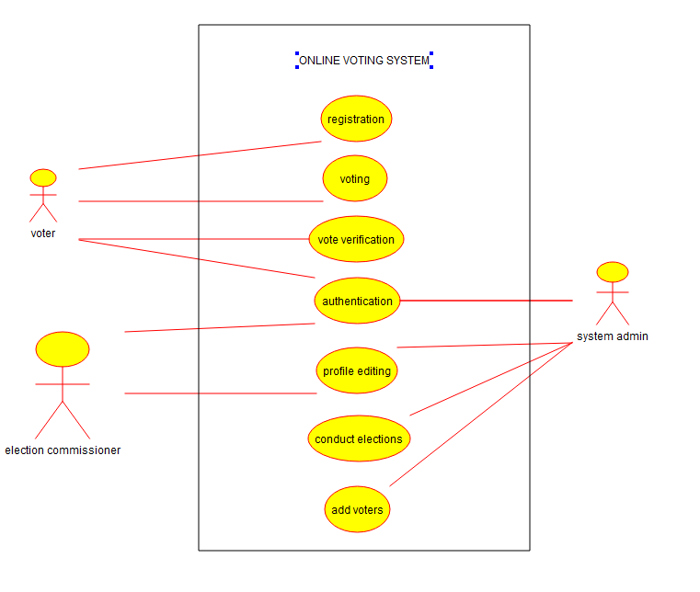

ACTIVITY DIAGRAM:

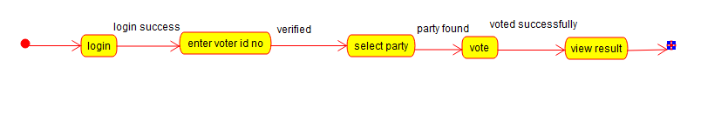

CLASS DIAGRAM:

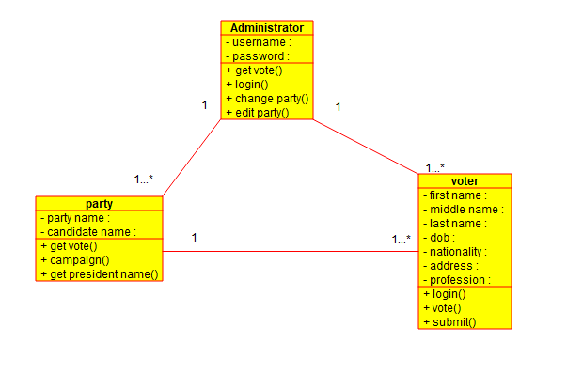

COMPONENT DIAGRAM:

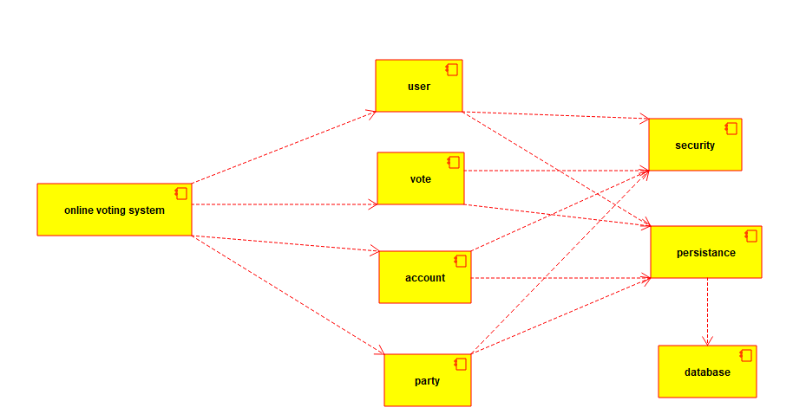

ACTIVITY DIAGRAM:

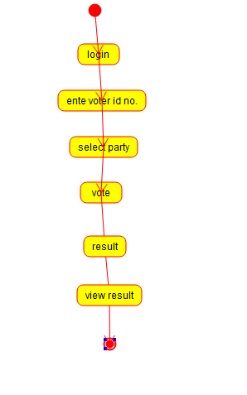

SEQUENCE DIAGRAM:

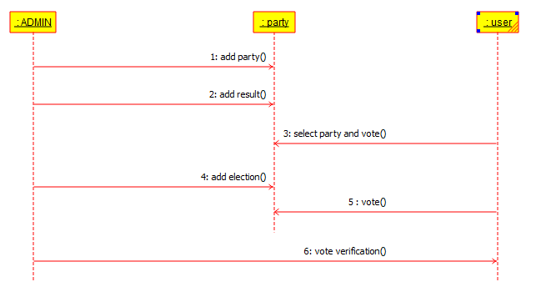

DEPLOYMENT DIAGRAM:

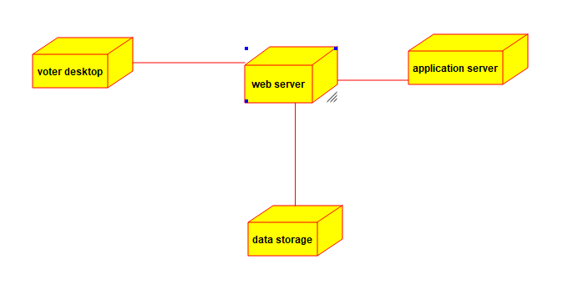

**SUPERMARKET MANAGEMENT SYSTEM:**

CLASS DIAGRAM:

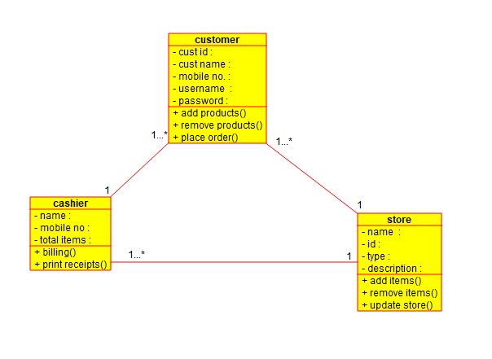

USECASE DIAGRAM:

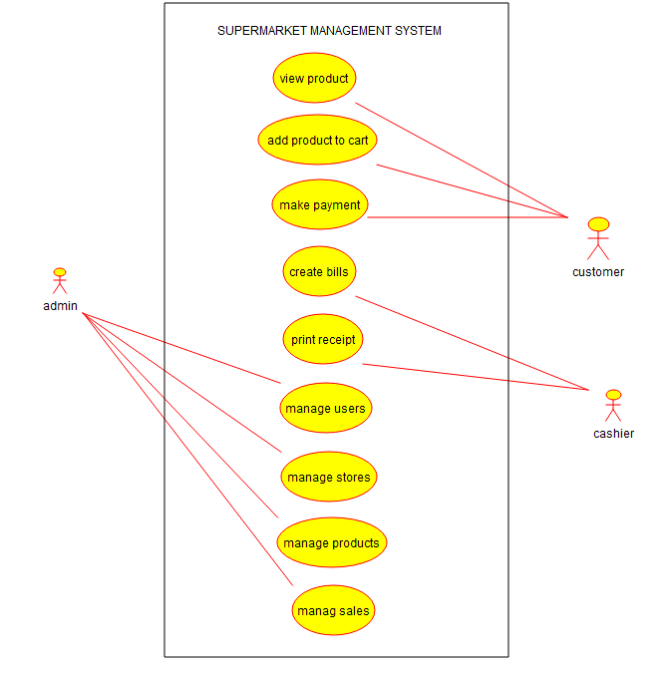

STATE DIAGRAM:

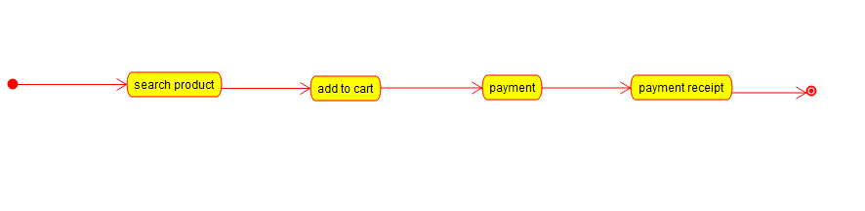

COMPONENT DIAGRAM:

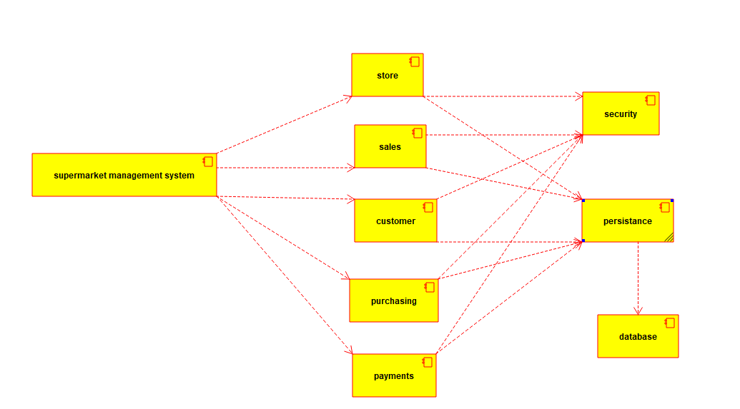

ACTIVITY DIAGRAM:

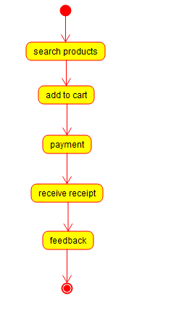

DEPLOYMENT DIAGRAM:

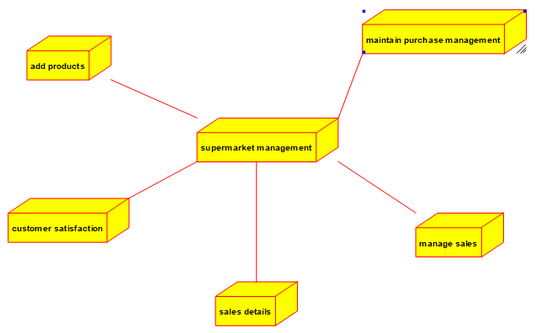

SEQUENCE DIAGRAM:

